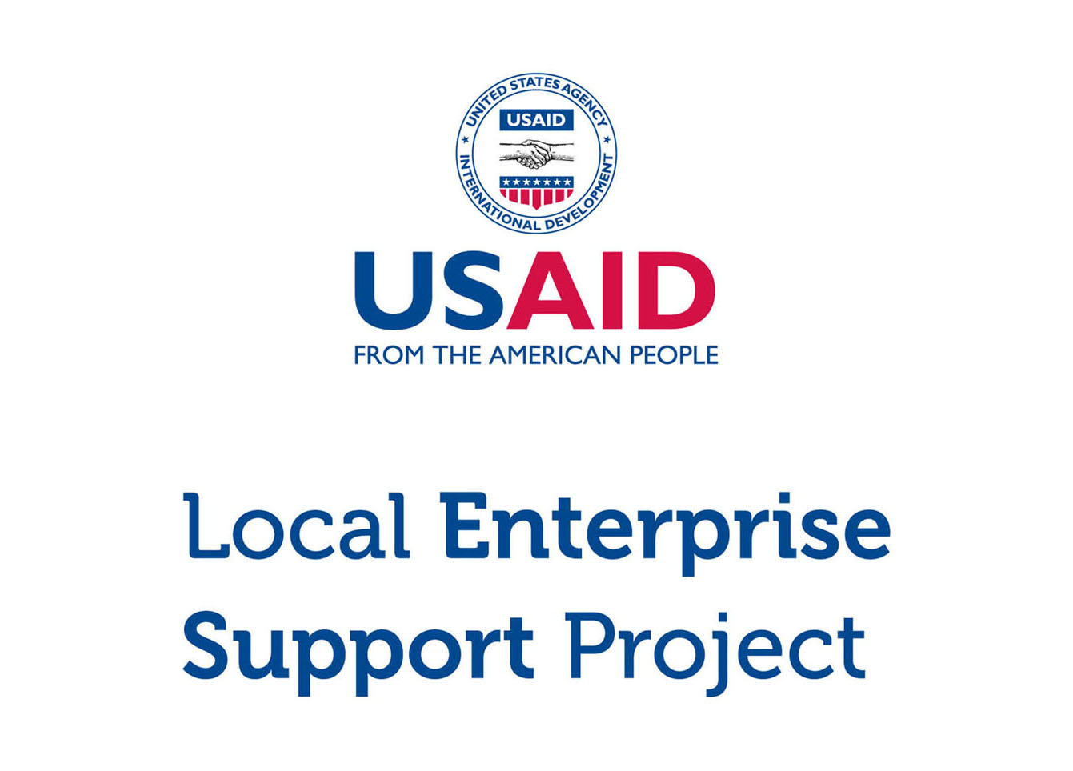

**Micro and Small Enterprise (MSE) Survey**

Results for Karak Governorate

Tuesday, March 15, 2016

**DISCLAIMER**

The USAID Jordan Local Enterprise Support (LENS) Project is funded by the United States Agency for International Development (USAID) and implemented by FHI 360. This report is made possible by the generous support of the American people through the United States Agency for International Development (USAID). The contents are the responsibility of FHI 360 and do not necessarily reflect the views of USAID or the United States Government.

**ACKNOWLEDGEMENTS**

This report was written by Bryanna Millis and Rafael Pilliard-Hellwig, with contributions from Faisal Awartani, Muin Khoury, Edmund Morris, and Jonathan Peters. The report was translated by Dania Mousa and Shadi Al Rawashdeh.

# Highlights

|  |  |  |
| --- | --- | --- |
| 5,513  MSEs |  | MSES ARE THE MAJORITY > There are an estimated 5,513 micro- and small-enterprises in Karak. Roughly three in four MSEs are single-person businesses, and two thirds operate in retail and trade. |
|  |  |  |
| 11%  WOMEN |  | MSES ARE MALE-DOMINATED > Only 11.1% of Karak’s MSEs are woman-owned. Women who have MSEs are more likely than men to earn less, to operate out of home locations, and to work out of necessity. |
|  |  |  |
| 7/10  ARE REGISTERED |  | MSES EXIST ON PAPER > Despite the fact that most MSEs do not pay tax and few have employees, 70.8% are nonetheless registered with the Ministry of Industry and Trade. |
|  |  |  |
| 5 YEARS  IN EXISTENCE |  | MSES ARE NACENT > The typical MSE has been in business for five and a half years. 88.3% of businesses in Karak believe they will continue to operate for at least 3 years. |
|  |  |  |
| 300 JD  PROFIT |  | MSES STRUGGLE TO GET BY > MSEs that make profit report a median bottom line of 300 JD per month (usually excluding the MSE owner’s own salary). 60.7% of MSEs are losing money or struggling to live comfortably. |
|  |  |  |
| 11% USE  COMPUTERS |  | MSES ARE DIGITALLY ABSENT > Only 10.7% of businesses use a computer in the course of their work. 17.0% use social media either for work or personal purposes. |
|  |  |  |
| <12%  PENETRATION |  | MSES LACK COLLECTIVE POWER > Memberships in associations are weak. With the exception of the chambers, the penetration rate for trade associations, business groups, and cooperatives is less than 12%. |
|  |  |  |

Table of Contents

Introduction 5

General Demographics 6

Contracts 17

Workforce 18

Firm Performance 21

Access to Finance 24

Systems, Processes and Networks 27

Policy and Regulations 31

Data was compiled using data file “**new_lens_usa_fix_pswt.sav**” (MD5 hash: 3958a9180d)

# Introduction

## About USAID LENS

The USAID Jordan Local Enterprise Support Project (LENS) is a five-year project to encourage the long-term economic growth and development potential of underserved Jordanian communities. USAID LENS combines local economic development with private sector development initiatives to help create jobs and sustainable growth that is inclusive of women and youth.

LENS’ systemic approach to local economic development is meant to catalyze inclusive local and regional economic networks in a business-enabling environment, while developing the competitiveness, sustainability and growth of micro and small enterprises.

## About the Survey

Although Jordan’s economy is dominated by micro and small enterprises (MSEs).[1] relatively little is known about them. To overcome this informational gap, USAID LENS conducted a survey of MSEs in 2014-2015 to better understand Jordanian enterprises and to assess the major barriers and opportunities for growth. The study covers general demographics, workforce trends, firm performance, access to finance, processes and networks, and the impact of the Syrian refugee crisis.

The survey consists of 86 questions in a double sampling design with stratification. The data gathers representative information for all MSEs operating in the governorates of Amman, Zarqa, Irbid, Karak, Tafilah, and Aqaba.[2] Although the study is not intended to be national in scope, the target population of the six areas collectively capture 60% of the kingdom’s population.

As a complex survey, the research design was undertaken using probability sampling in two phases. In the first phase, 977 geographic clusters were randomly selected from districts in each area. From these clusters, 97,347 households were contacted through door-to-door interviews, of which 10,197 reported owning a business. A sub-sample of 6,385 MSEs was then drawn, stratified by sector governorate. 4,721 of these MSEs were then successfully surveyed (986 in Karak).

This report focuses exclusively on results for the governorate of Karak. Findings are taken from USAID LENS’ MSE survey, and can reliably be generalized to all MSEs within this geographic boundary.[3]

# General Demographics

## Firm Characteristics

Based on the survey research, there are an estimated 5,513 MSE owners in Karak governorate.[4] An overwhelming majority of these are men (88.9%).

The proportion of man-owned to woman-owned businesses is generally consistent with government figures. According to the Department of Statistics (DOS), women account for only 13.0% of the labor force nation-wide. According to the survey, 16.7% of businesses in Karak either employ women or are managed by one.

|  |  |  |  |  |  |
| --- | --- | --- | --- | --- | --- |
| **Demographics (Karak)** |  | **Sample** |  | **Population Estimate[5]** | |
|  |  | *n* = 986 |  | *N* = 5,513 | % of group |
| **By Select Sector[6]** |  |  |  |  |  |
| Food processing |  | 433 |  | 1956 | 35.5% |
| Tourism |  | 67 |  | 391 | 7.1% |
| Transport |  | 87 |  | 369 | 6.7% |
| ICT |  | 30 |  | 162 | 2.9% |
| Other |  | 369 |  | 2635 | 47.8% |
| **By Sex of the Owner** |  |  |  |  |  |
| Men |  | 840 |  | 4,898 | 88.9% |
| Women |  | 146 |  | 614 | 11.1% |

Food Processing accounts for the largest of the four sectors above, representing 35.5% of all MSEs in Karak. Tourism follows with 7.1%, Transport with 6.7%, and ICT with 2.9%. MSEs outside of these select sectors account for the remaining 47.8%.

Karak has a number of subsectors that are proportionally more important. Compared to other areas surveyed, Karaki MSEs are more likely to be in retail sale of good, beverages and tobacco, animal production, repair of computers and communication equipment, agriculture of perennial crops, manufacturing of food products, and private education. [7]

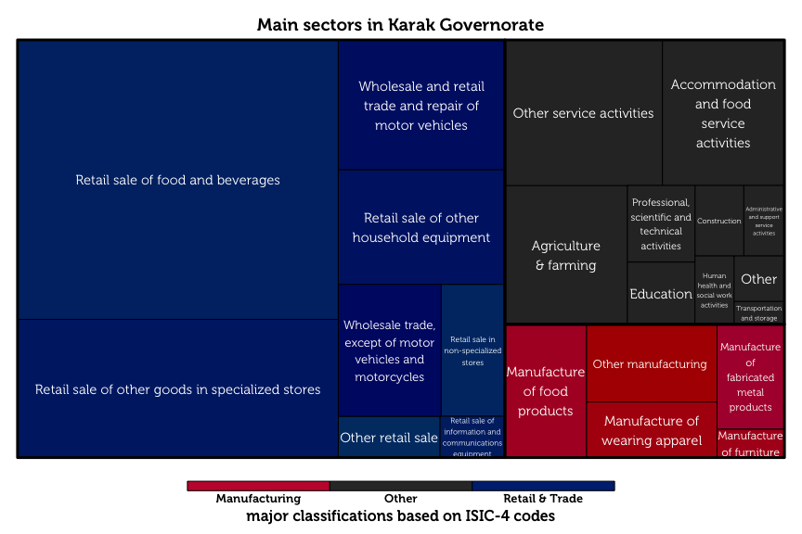

The tree map diagram above shows the relative sizes of each business category, as classified by ISIC-4 codes. Retail and trade dominates as the largest sector (63.5%), followed by manufacturing (11.6%).

## Respondent Characteristics

The typical MSE owner in Karak is a married, 42-year old male with secondary school as his highest level of education. 66.9% of these owners have families of moderate size (4 – 7 members). Male business owners are typically the primary earners of their household, in sharp contrast to female MSE-owners, who are rarely the breadwinners of their families.

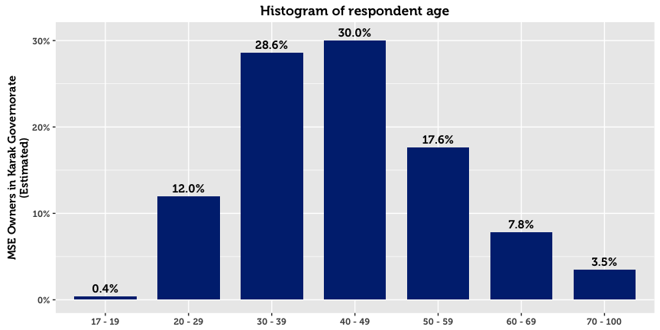

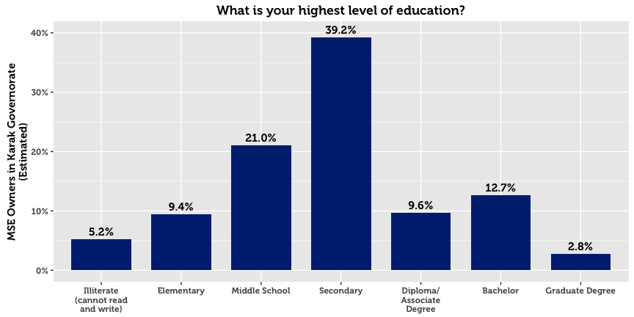

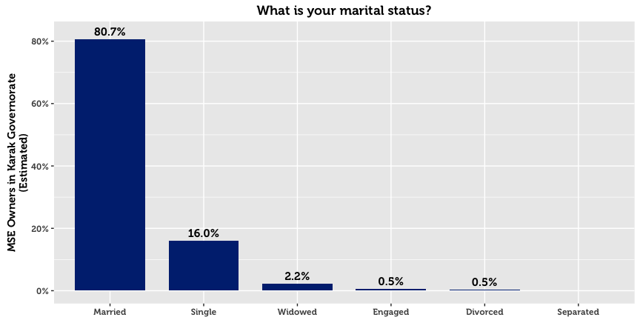 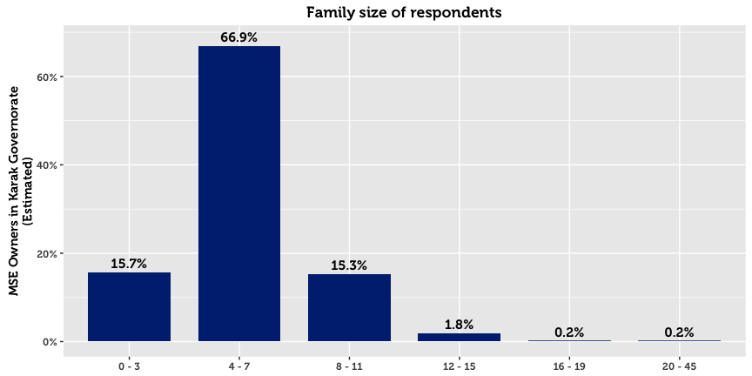

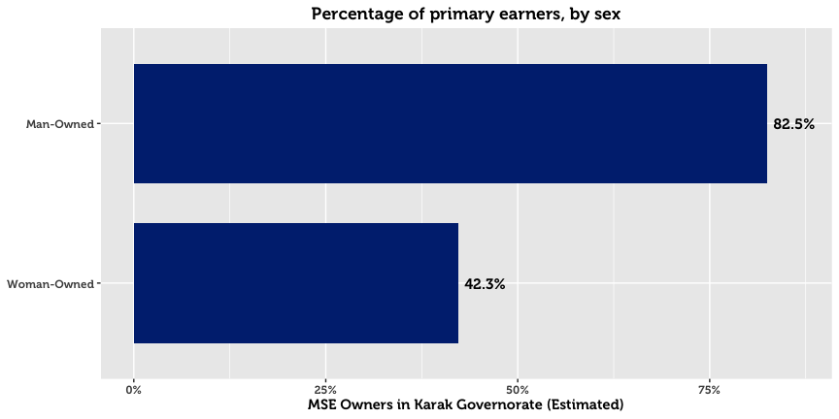

## Establishment, Registration & Business Continuity

The survey reveals that the typical company is one that was established in 2009[8] (compared to a median of 2008 for the governorates of the north). 88.3% of the governorate’s establishments believe that they will continue with the business over the next three years.

A higher number of businesses are registered with the Ministry of Industry and Trade (MoIT) than anticipated. 70.8% of all MSEs in Karak are registered, a figure that is dramatically higher for male-owned businesses (76.2% for men compared to 28.2% for women). Registered businesses tend to be older than unregistered businesses by an average of two years.

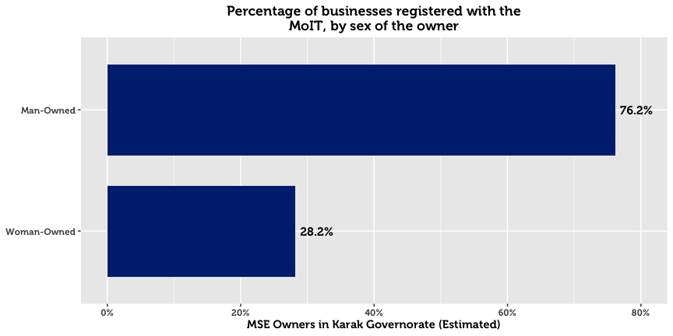

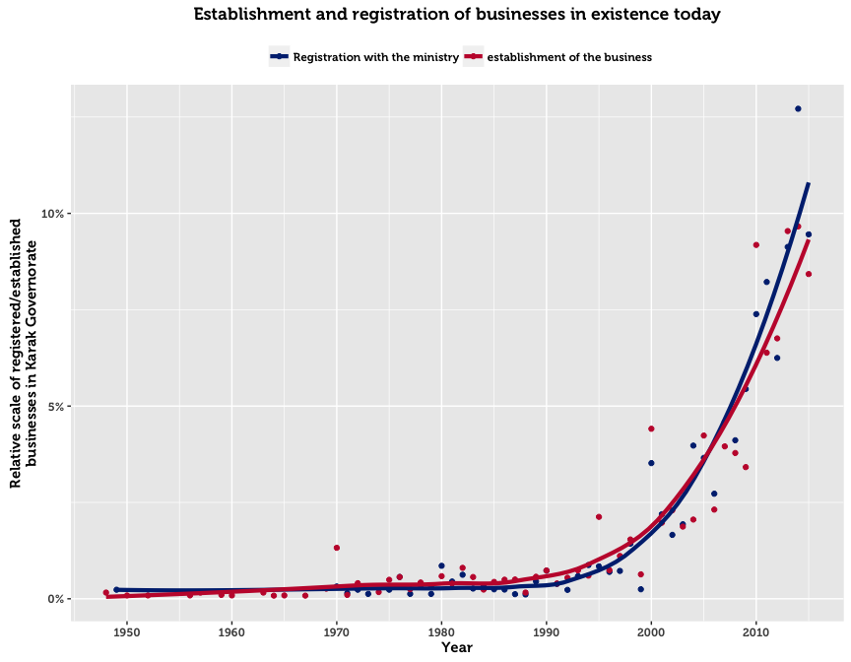

The above chart plots the frequency of business establishments and registrations by year. Almost all registered businesses were established and registered in the same year. The upward trend in registrations over time is most likely explained by three factors: (1) growth in the population of Jordan, (2) initiatives by the government to increase awareness and simplify the registration process, and (3) the fact that former establishments are not captured by the survey. The third reason implies that businesses that existed in the past but no longer operate become excluded from the sample. Such business may have gone out of business for financial reasons, or ceased to exist due to the passing of the owner.

For those who chose to register, two main reasons emerge. The first reason is that registration is legally compulsory for their type of business (cited by 41.4%). The second is that MSE owners fear fines or harassment by police and authorities (cited as the primary reason by 39.9%). Government support, availability of insurance or official protection, and access to finance were not considered to be important primary motivations for business registration.

On the flip side, the dominant explanation cited by half of the unregistered MSEs in Karak is that the owners do not see any benefits from officially registering their business (52.7%). Other reasons such as cost, lack of understanding, and administrative complexity are far less important.

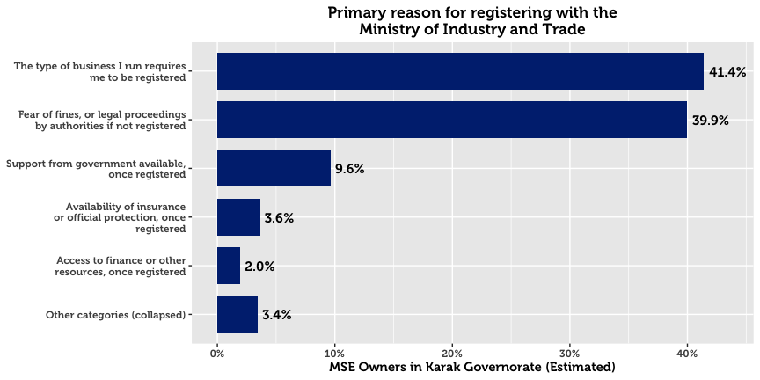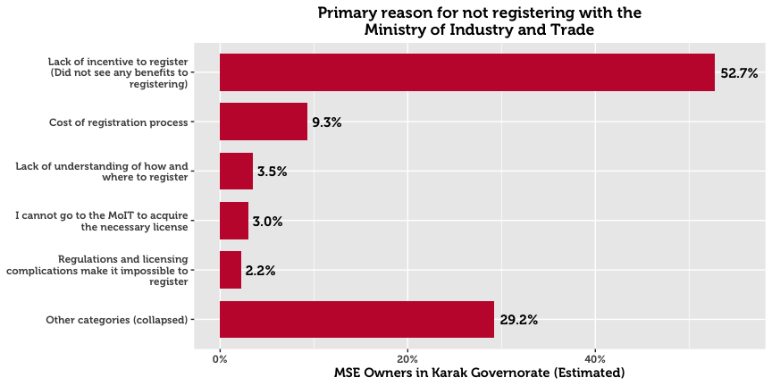

## Seasonal Business

An estimated 85.7% of MSEs operate all year round. Woman-owned businesses, home-based businesses, and non-registered enterprises are more likely to be seasonal.

## Working Hours

63.5% of business owners work 49 hours a week or more. This trend of long work hours is particularly pronounced in the Transport sector. Registered businesses are also more likely to put in long hours.

## Location of Conducting Business

In Karak, the majority of business is conducted from a fixed location outside the home (85.0%). This primacy of fixed locations out of the home is consistent across sector and sex of the business owner. However, it is much less pronounced for woman-owned businesses, as men are 2.3 times as likely to operate out of from a fixed location out of the home.

In stark comparison, 13.8% of MSE are home-based[9]. Gender differences on this dimension are high: 58.1% of women-owned businesses operate from their own home, compared to 8.2% for man-owned businesses. Certain industries are much more likely to be home based compared to other industries. These include animal production, processing and preserving of fruit and vegetables, manufacture of dairy products, building completion and finishing, retail sale in non-specialized stores, pre-primary and primary education, and manufacture of wearing apparel. It is noteworthy that most of these home-based businesses have specialized installations for their operations, suggesting that their enterprises are not merely casual and warrant capital investment.

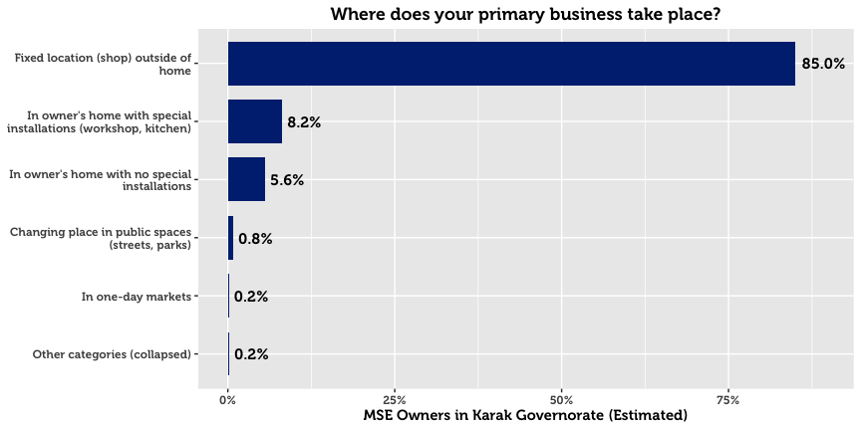

## Business Motivation

The main motivation for starting an MSE is the desire of individuals to own their own business. 38.9% of MSEs state that this is the main reason they started their business. The second most popular reason is to generate income for the individual’s family (33.7%), followed by a desire to work in the industry (9.6%).

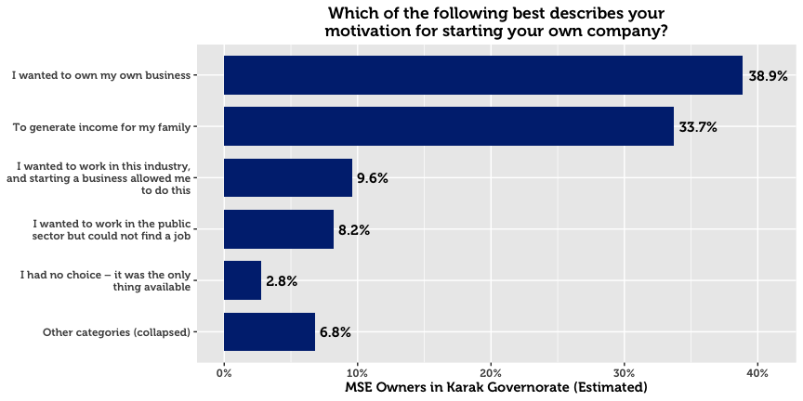

## Conducting Other Business

30.5% of MSE owners in Karak have more than one business or income-generating project. In fact, of the governorates in the study, the southern ones are three times as likely as those of the north to have another business. Men are also more likely to have a secondary business (by a factor of 1.2).

## Legal Ownership of Business

76.8% of businesses in Karak are self-owned. 6.7% are owned by a male family member, and 4.6% by a male non-family member.

## Form of Incorporation

The majority of MSE owners who are formally registered exist as sole proprietorships (92.8%). Others are typically either General Partnerships (0.9%) or Limited Liability Companies (0.6%).

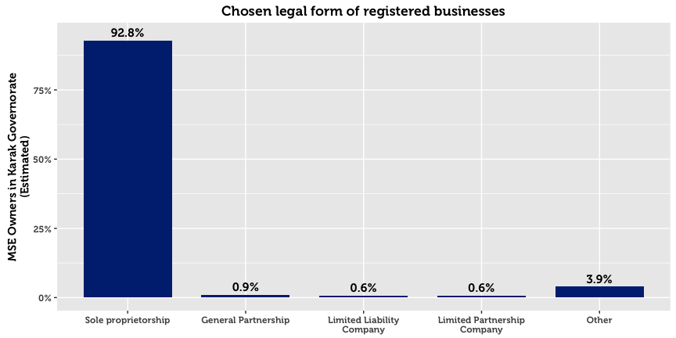

## Licensing

MSEs are by and large licensed with their municipalities. However, there exists a small subset that claim to be registered but not licensed (3.5%), and a subset that claim to be licensed but unregistered (5.3%). This may point to either a) misunderstanding of the question on behalf of the respondent, b) an expired license from the municipality, or c) an informal or illicit acquisition of a license from the municipality. As one might expect, home-based businesses have far higher chances of being unlicensed.

The two primary reasons cited by MSE owners for not being licensed are that it is not required for their business (31.0%) and that they saw no benefits to doing so (27.4%). A quarter of respondents cited “other reasons” perhaps due to reluctance to answer truthfully to a sensitive question.

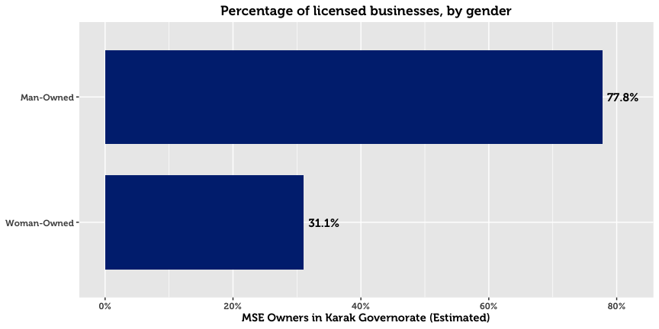

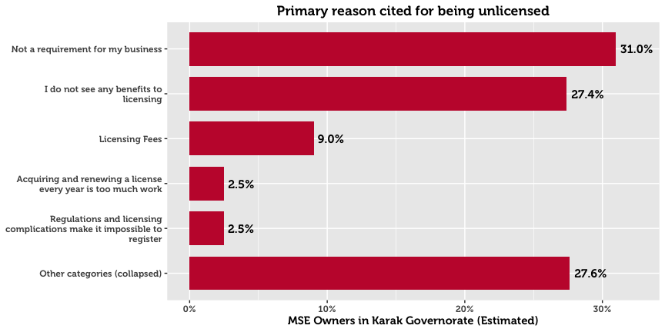

# Contracts

A large majority of surveyed enterprises never sign contracts: 85.7% of all MSEs. However, a higher proportion report signing contracts either always or often in Karak (9.6%) than in any other governorate. In the event of a dispute, over half of MSE owners opt to take legal proceedings (55.0%). This is a remarkably higher proportion than in Amman, Irbid, and Zarqa, seemingly evidencing a greater level of trust in the court system. 16.3% report that they will resort to doing nothing. And finally, a comparatively small proportion (4.7%) will resort to an informal meeting, though family intervention is more common at 12.0%.

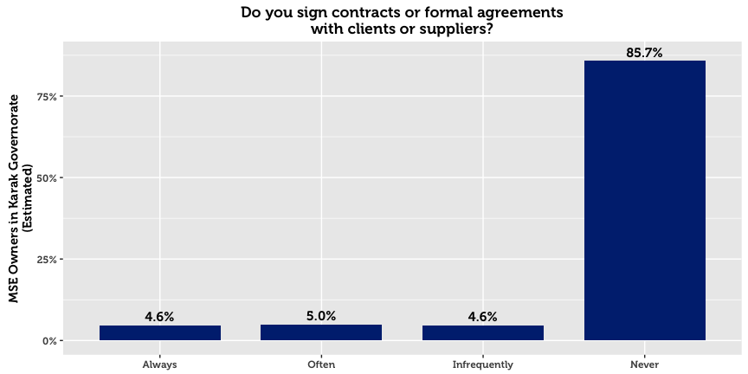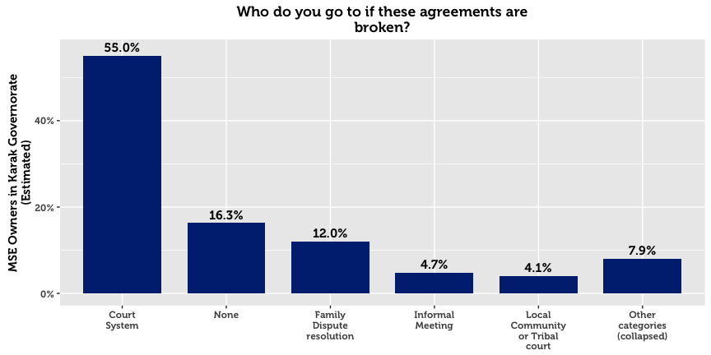

# Workforce

One third of Karak’s MSEs hire employees—33.5%. 27.8% of MSE’s employ full-time Jordanian workers, with 14.8% employing just one full time worker, 7.4% employing two workers, and 5.5% employing three or more. Only 9.2% of MSEs employ part-time workers, of which two thirds just employ one worker. Employment of women is rare, as only 5.8% of MSEs have woman employees (compared to 23.5% that have male employees). The few subsectors that are likely to hire women include education, other service activities, medicinal and dental practice activities, and office administration.

Half of MSEs with employees in Karak did not hire any new employees in the last year. 19.7% hired exactly one employee. 6.2% of all enterprises in Karak report employing workers below the age of 18.

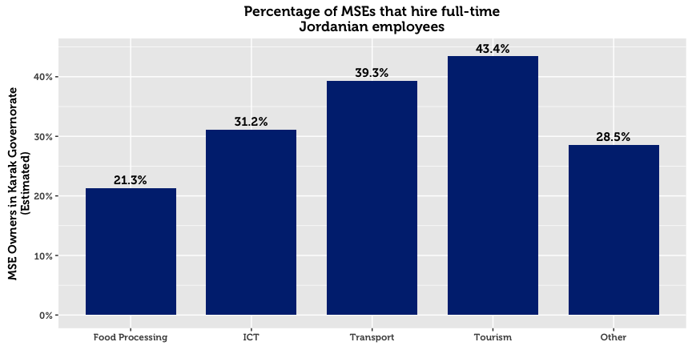

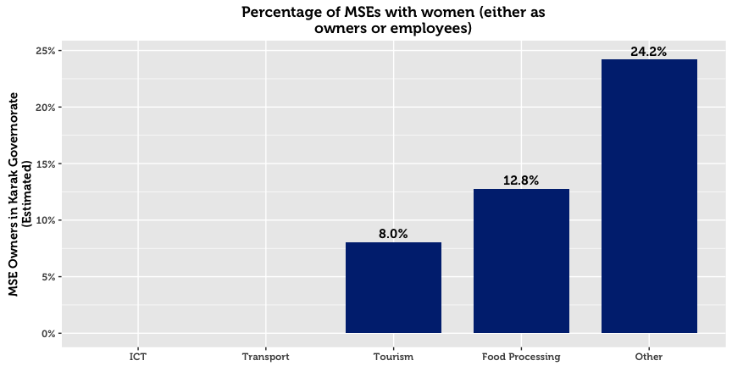

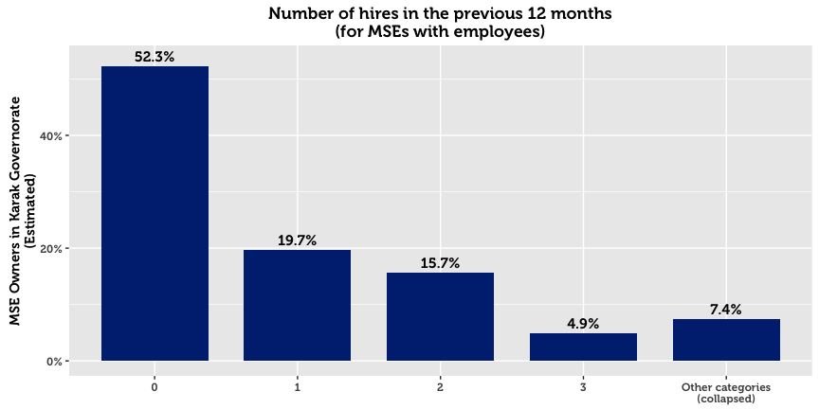

40.3% of enterprises with employees hire between 1-3 workers. Of the MSEs that hire workers, 74.9% say that none left their business during the last 12 months. Of those that experience talent loss, the major attributions are to personal reasons, employees leaving for a public sector job, and employees leaving to start their own business.

|  |  |  |
| --- | --- | --- |
| Primary Reason for Employee Loss (Karak) |  | All |
|  |  | *N* = 464 |
| Personal reasons |  | 29.5% |
| Employee took government or public service employment |  | 23.4% |
| Employee left to start their own business |  | 9.5% |
| Working hours were not suitable |  | 6.3% |
| Employee’s salary demands are too high |  | 6.0% |
| Other reasons (remaining categories collapsed together) |  | 25.3% |

## Employee Training

Only 26.2% of MSEs with employees offer their workers in-house training. They typically offered technical training or informal mentorship. External trainings for employees are less common at 9.3%.

|  |  |  |  |  |
| --- | --- | --- | --- | --- |
| **MSEs that Offer Employee Training* (Karak)** |  | **In-House** |  | **External** |
|  |  | 26.2%  *N* = 484 |  | 9.3%  *N* = 172 |
| Technical training/advice in your industry |  | 21.8% |  | 7.8% |
| Informal advice/mentorship |  | 20.4% |  | 5.4% |
| Marketing assistance/market information |  | 12.1% |  | 4.5% |
| Business Management training |  | 10.6% |  | 4.9% |
| Human resources/soft skills training |  | 6.7% |  | 3.7% |
| Recordkeeping |  | 6.0% |  | 3.3% |
| Other |  | 7.9% |  | 4.2% |
| *\* Domain of analysis comprises only of companies with employees (1,849 total)* | | | | |

## External Assistance

It is estimated that only 4.3% of MSEs in Karak receive technical assistance.[10] A very small number receive assistance[11] from informal networks (1.2%), donor-funded programs (1.1%), a Business Service Provider (0.9%), government (0.9%), or a Private Company (0.8%).

# Firm Performance

60.7% of MSE owners report that they are either losing money or struggling to live comfortably. Only 35.4% of surveyed enterprises maintain that their business allows them to live comfortably, and 3.9% claim that their company allow them to live well above their living costs.

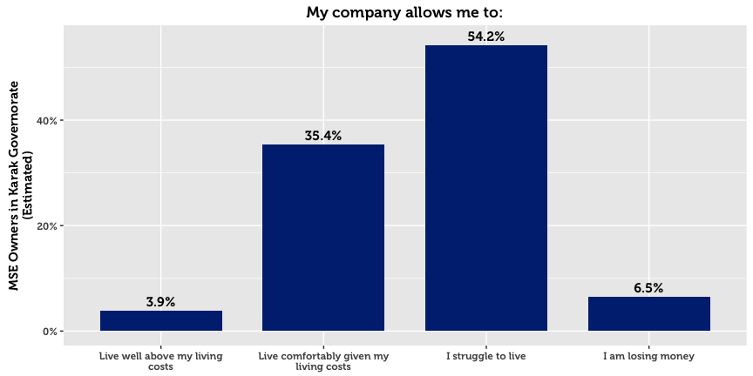

## Barriers to Economic Growth for MSEs

Although 74.8% of MSEs in Karak wish to expand their business, many of them face challenges in doing so. MSE owners were asked to state whether they agreed or disagreed that the following items represent barriers to the development their firms:

|  |  |  |  |  |  |
| --- | --- | --- | --- | --- | --- |
| **Barriers to Success (Karak)** |  | **All** |  | **By Sex** | |
|  |  | *N* = 5,513 |  | Men | Women |
| Low demand |  | 65.9% |  | 65.8% | 66.7% |
| Low purchasing power |  | 64.0% |  | 63.6% | 67.4% |
| Price of inputs increased |  | 51.3% |  | 51.8% | 47.0% |
| Lack of financial support |  | 41.1% |  | 41.1% | 41.0% |
| Lack of family support |  | 36.8% |  | 35.1% | 50.3% |
| Lack of appropriate suppliers |  | 33.2% |  | 33.2% | 33.3% |
| Uncompetitive products |  | 32.8% |  | 32.0% | 39.2% |
| Cannot compete with quality of the products |  | 31.6% |  | 31.6% | 31.9% |
| Lack of market information about the markets |  | 26.8% |  | 27.1% | 24.7% |
| Lack of human resource options |  | 26.5% |  | 27.1% | 21.6% |
| Lack of proper marketing skills |  | 25.7% |  | 25.4% | 28.1% |
| Unreliable transportation network |  | 25.1% |  | 25.0% | 26.1% |
| Weak technical support or skills in this area |  | 24.1% |  | 24.4% | 22.2% |
| Lack of management skills |  | 22.5% |  | 22.3% | 23.8% |

The majority of firms believe that the major barriers are macroeconomic in nature. Low demand and low purchasing power top the list of barriers to success. Despite the fact that most MSEs lack many formal processes and mechanisms such as a bank account or trainings, most do not perceive this a major gap or barrier. More MSEs in Karak indicated that a lack of appropriate suppliers was a barrier to development compared to the governorates of the north (33.2% in Karak, compared to a combined average of 19.6% for the governorates of the north).

## Financial Performance

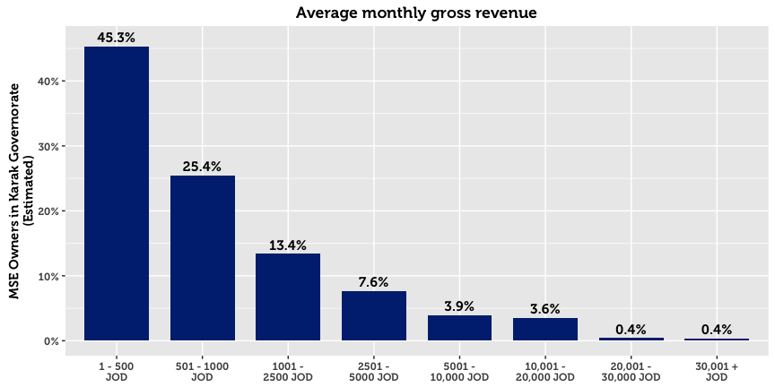

45.3% MSEs in Karak report a monthly turnover of JOD 500 or less (a comparatively smaller proportion than other governorates). However, as many as 10.7% do not know their revenue or refused to answer when asked about it. On average, non-registered enterprises, home-based businesses, and single-person MSEs report significantly lower gross revenue.

Profit is a more sensitive issue: Although 63.9% report finishing the month in the black, 10.7% either refuse to disclose the exact amount, or do not know the amount. Nevertheless, of those who make profit and are willing to share this information, the median profit is 300 JOD. The median amount of savings per month in Amman is 200 JOD.

|  |  |  |
| --- | --- | --- |
| 14.1%  Of MSEs in Karak make  monthly savings |  | 79.5%  Of MSEs in Karak make no  monthly savings |

# Access to Finance

Over half of micro and small enterprises in Karak generate enough money to sustain themselves without outside financing. Although many MSE owners struggle to live comfortably, as many as 23.6% say that they do not need a loan. Accordingly, financial institutions do not play a role in the economic development of most MSEs, evidenced by the fact that only 19.5% of MSEs have applied for credit in the last 12 months (however this is a higher proportion than in any other governorate). Being in the Middle East, religious reasons also have a part to play in this phenomenon. Although the rise of Islamic Banking products has expanded the market, 18.5% of MSE owners cite religious prohibition as the main reason for not taking a loan. The overall availability of credit may be another supporting factor. However, another likely explanation is that MSE owners do not interact much with providers of credit, or even know about money markets. This is likely in view of the fact that only 17.1% of MSEs have bank accounts, that most loan applications get approved (89.0% reported approval), and that only 13.5% believe that they only have one source of credit to their disposition.

Approved loans are typically used for business purposes, primarily to buy more resources, add new products or business activities to the current business, or to improve or upgrade products already being sold. Only in limited cases is financing used to pay off company debt (5.3%), expand or purchase property (5.1%), or pay-off personal debts (3.7%).

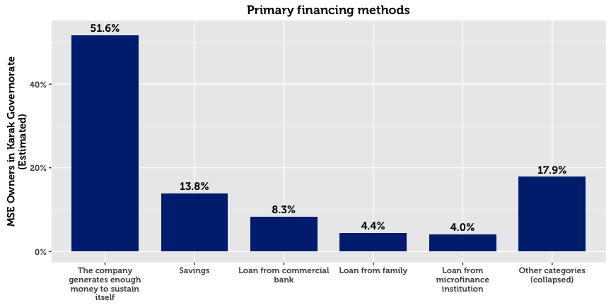

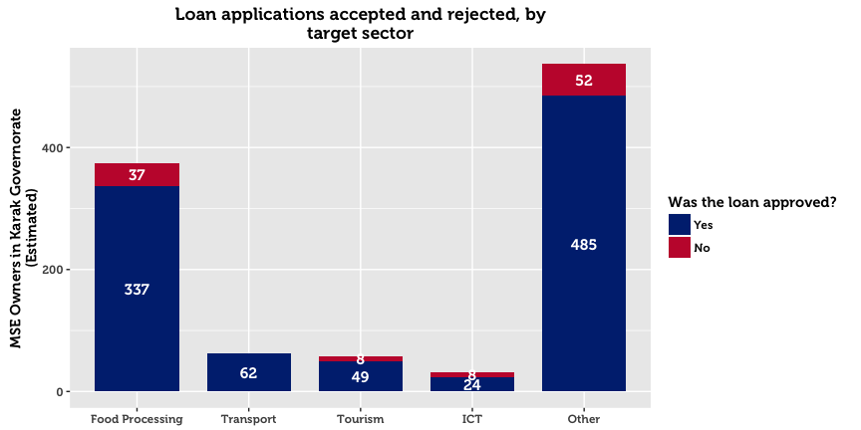

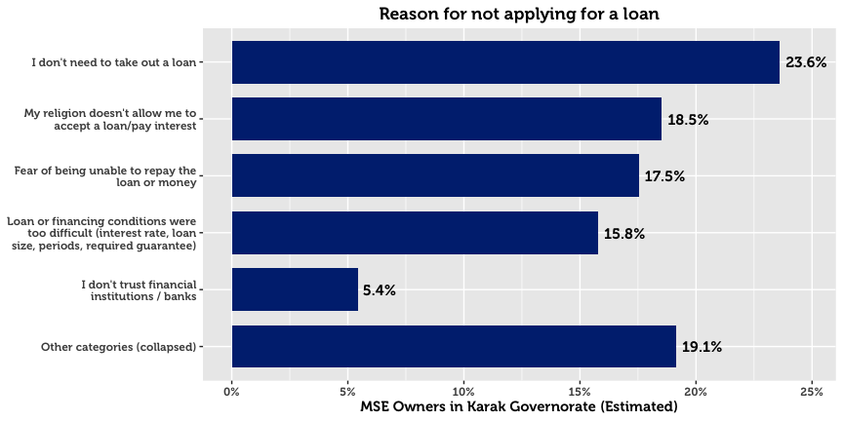

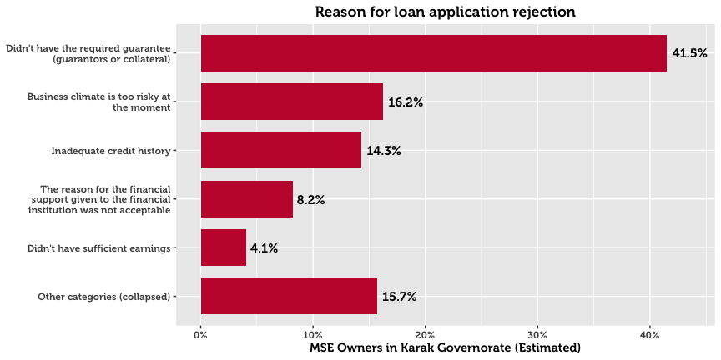

Of those who receive a loan, 62.2% receive it from a bank, and 28.4% from a microfinance institution. Very few MSEs in Karak report financing from government programs such as JEDCO and IRADA (1.9%), private money lenders (1.5%), or international donors or donor-funded projects (0.4%). When asked about the primary reasons for choosing a specific institution, 40.3% cite that their institution of choice offers the best financial prospects. 14.5% cited that they choose a particular provider because they are easy to understand and follow simple procedures.

Men and women differ greatly in the amount of money requested in loan applications. Whereas men request a median of 3,756 JOD, women MSE owners are far more conservative at 1,714 JOD. These differences may be confounded by the fact that the sex of the business owner is strongly associated with the subsector and location of the business.

# Systems, Processes and Networks

Online and offline use of computers within MSEs is minimal, at 10.9% of firms. Smart phones are used by 38.8%, while ordinary mobile phones are used by 50.2% of MSEs.

|  |  |  |  |  |  |
| --- | --- | --- | --- | --- | --- |
| **Resource Use (Karak)** |  | **All** |  | **By Sex of the Owner** | |
|  |  | *N* = 5,513 |  | Men | Women |
| Mobile Phone |  | 50.2% |  | 50.3% | 48.9% |
| Smart Phone |  | 38.8% |  | 38.5% | 41.3% |
| Vehicle |  | 22.6% |  | 23.8% | 12.9% |
| Social Media (work purposes) |  | 9.1% |  | 9.3% | 7.3% |
| Computer (with internet) |  | 8.9% |  | 9.3% | 5.5% |
| Computer (without internet) |  | 6.8% |  | 6.9% | 5.7% |
| Public Internet Location |  | 5.0% |  | 5.1% | 3.6% |
| Email |  | 4.2% |  | 4.5% | 1.5% |

Only 9.1% use social media as part of business operations (17.0% for either work or personal). Naturally, this rate is more pronounced in the ICT sector, for which the digital environment is the main mode of work. The low number of social media users suggests that few MSEs understand social media, and that any target audience for social media is small. Email is even less ubiquitous, at 4.2%

## Cooperation with Other Businesses[12]

In the previous 12 months, 79.8% of MSEs had often or always cooperated with other businesses in some capacity. The most frequent type of horizontal linkage was cooperating to purchase inputs, services, or equipment (67.1%), followed by cooperation on market products/services (44.2%) and industry discussions (34.3%). Roughly one third worked with other businesses to transport goods to points of sale.

Other forms of cooperation were less common however, with most MSEs rarely or never cooperating on giving trainings or on receiving certifications (such as ISO, International Accreditation, First Aid etc.).

|  |  |  |
| --- | --- | --- |
| **Horizontal Linkages* (Karak)** |  | **All** |
|  |  | *N* = 5,513 |
| Purchase inputs, services, or equipment |  | 67.1% |
| Market products or services |  | 44.2% |
| Discuss information about the industry you are in |  | 34.3% |
| Transport goods to points of sale |  | 31.7% |
| Other |  | 24.5% |
| Receive trainings |  | 21.2% |
| Receive certifications |  | 14.1% |
| *\* captures owners who responded “often” or “always” for each form of cooperation* | | |

## Corruption

With respect to bribery, 89.8% of enterprises report that they have rarely or never been asked for an informal payment.

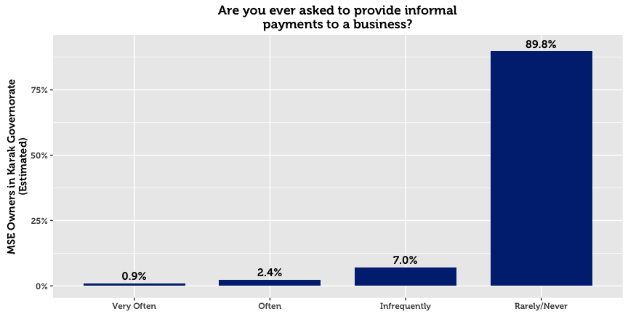

## Financial Planning

Three out of four of businesses keep some form of financial records. However, the vast majority of businesses record their finances on paper (73.9%). A quarter of businesses keep no financial records whatsoever. A further indication of the lack of planning and financial organization is that only 51.0% compare performance against business goals.

## Memberships & Access to Networks

For the most part, MSEs in Karak are not part of associations. With the exception of the Chambers of Commerce and Industry (for which 34.8% and 23.5% of MSEs were members, a higher proportion than in all other governorates), no association garners more than 12.0% of MSEs in the governorate. These categories included professional or trade associations (11.2%), cooperatives (6.8%), women’s groups (3.6%), micro-finance groups (3.4%), youth groups (3.3%), informal savings or loan groups (3.2%), ward or village committees (2.6%), and NGOs (2.5%).

|  |  |  |  |  |  |
| --- | --- | --- | --- | --- | --- |
| **Memberships (Karak)** |  | **All** |  | **By Sex of the Owner** | |
|  |  | *N* = 5,513 |  | Men | Women |
| Chamber of Commerce |  | 34.8% |  | 37.7% | 11.7% |
| Chamber of Industry |  | 23.5% |  | 25.5% | 7.6% |
| Formal trade, business, or professional association |  | 11.2% |  | 11.3% | 10.3% |
| Cooperative |  | 6.8% |  | 6.6% | 8.3% |
| Women’s group |  | 3.6% |  | 3.8% | 1.6% |
| Microfinance group |  | 3.4% |  | 3.4% | 3.5% |
| Youth group |  | 3.3% |  | 3.5% | 2.0% |
| Informal savings or loan group |  | 3.2% |  | 3.6% | 0.0% |
| Ward or village committee |  | 2.6% |  | 2.8% | 0.5% |
| NGO |  | 2.5% |  | 2.8% | 0.5% |

Despite the fact that few participate in formal networks, 69.4% say they can get a meeting with the mayor or municipal council, a relatively high proportion nationally. This is lower for woman-owned businesses (58.8%) compared to man-owned establishments (70.7%).

# Policy and Regulations

79.8% of MSE owners in Karak believe they know about the laws and regulations that govern their firm. As ‘digital literacy’ is relatively low, two thirds resort to traditional sources of information. In particular, MSE owners go to their municipality, friends and family, or lawyer for information. Only 7.4% resort to government websites.

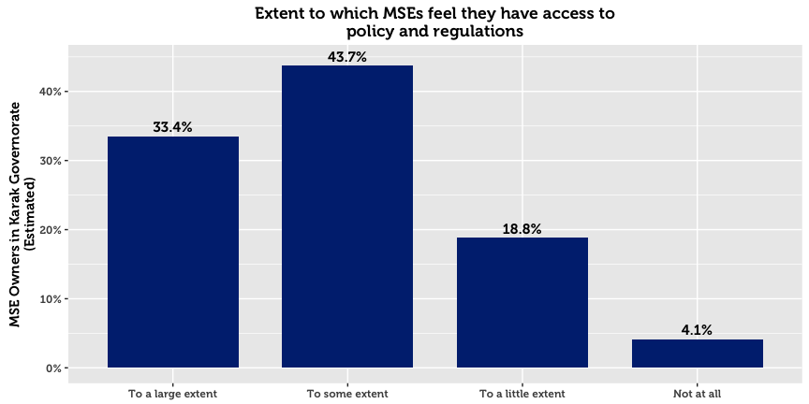

|  |  |  |  |  |  |
| --- | --- | --- | --- | --- | --- |
| **Policy Sources (Karak)** |  | **All** |  | **By Sex of the Owner** | |
|  |  | *N* = 5,513 |  | Men | Women |
| Local municipality |  | 35.6% |  | 37.6% | 20.1% |
| Family and friends |  | 28.8% |  | 26.7% | 45.5% |
| Lawyer |  | 13.8% |  | 14.5% | 7.6% |
| Government website |  | 7.4% |  | 7.9% | 3.5% |
| No use for this information |  | 4.2% |  | 3.6% | 8.8% |
| Do not know |  | 2.9% |  | 2.2% | 8.3% |
| Local businesses and enterprises |  | 1.5% |  | 1.5% | 1.5% |
| Business support center |  | 1.2% |  | 1.3% | 0.0% |
| Refused to answer |  | 0.0% |  | 0.0% | 0.0% |
| Other |  | 4.5% |  | 4.5% | 4.7% |

1. In this paper, micro- and small-enterprises are categorized in accordance with USAID LENS’ definition. A business (formal or otherwise) having fewer than 10 full-time employees (excluding the owner) is classified as a microenterprise, whereas businesses with 10 to 49 full-time employees, are categorized as small.
2. Throughout this paper, the area of “Amman” refers to the geographic area of Amman governorate, excluding the Greater Amman Municipality (“GAM”) which was excluded from the study. The area of “Aqaba” refers to the Aqaba Governorate, excluding the Aqaba Special Economic Zone (“ASEZA”).
3. Although results are representative of MSEs within each geographic area, results cannot be disaggregated on a more granular geographic level without compromising on acceptable sampling error rates. This is due to the clustering design in the first phase.
4. This total represents an estimate for the total number of MSE owners, without accounting for multiple-ownership. The survey reveals that 30.5% of business owners in Karak have a second business. The total number of MSEs is therefore higher than the total number of MSE owners. Throughout this report, we relax this strict distinction and commonly use language such as “X% of MSEs…” when referring to data about MSE owners.
5. In this report, “Population Estimate” means the absolute number of MSE owners in Karak, estimated using inclusion probabilities from the random sample. This statistical definition of “population” is not the same as the general understanding of the word in everyday language, which refers to the total number of people living within the boundaries of a nation state. Although many statistical publications use or when referring to these estimates, in this report we use the more intuitive notation *N* to denote population estimates, and *n* to denote unweighted sample counts.
6. Four sectors are examined throughout this report: Tourism, ICT, Transport, and Food Processing. These groupings are created on the basis ISIC-4 classifications collected in the survey, and are the primary data to reflect the four target sectors used for interventions in the LENS project.
7. Due to the large number of ISIC categories and the relative infrequency of most of them in the observed data, the search procedure for finding sectors of interest is conducted through statistical learning techniques, validated through resampling. This allows for most spurious relationships to be rejected.
8. Due to the high skew in the data, the median value (2010) is a more representative measure in comparison to the mean (2007).
9. In this report, a home-based business is any enterprise or income-generating project that operates from the owner’s home. As a result, this definition does not include MSEs operating in the homes of clients (maids, personal care, etc.).
10. Due to an error in the tablet software used for interviews, questions concerning technical assistance were only posed to MSE owners with employees.
11. Understood as financial or resource contributions from an international or local agency
12. Questions on cooperation with other businesses were only asked to SME owners in Aqaba, Karak, and Tafilah.